IGS-2712B
Industrial L2+ managed GbE Switch

Quick Installation and
Initial Configuration

Contents
Chapter 1 Introduction 1
Overview 1
Front View of the Switch 1
Rear View of the Switch 2
LED Descriptions 2
DIP Switch 4
Reset Button 5
Chapter 2 Installing the Switch 6
Package Contents 6
Mounting the Switch on a DIN Rail 6
Mounting the Switch on Wall (Optional) 7
Connecting the DC Power Cord 8
Connecting the DI/DO Relay Wires 10
Installing SFP Modules 11
Chapter 3 Initial Configuration of Switch 12
Initial Switch Configuration Using Web Browsers 12
Initial Switch Configuration Procedure 12
Chapter 4 Troubleshooting 15

Chapter 1 Introduction

Overview
This user guide describes how to install, configure, and troubleshoot the IGS-2712B, 12 Ports Industrial L2+ managed GbE Switch.
By reading this user guide, users can perform the following tasks:
- To check the switch status by reading the LED behavior
- To reset the switch or to restore the switch to factory defaults
- To install the switch
- To use a Web browser to initially configure the switch
- To troubleshoot the switch

Front View of the Switch

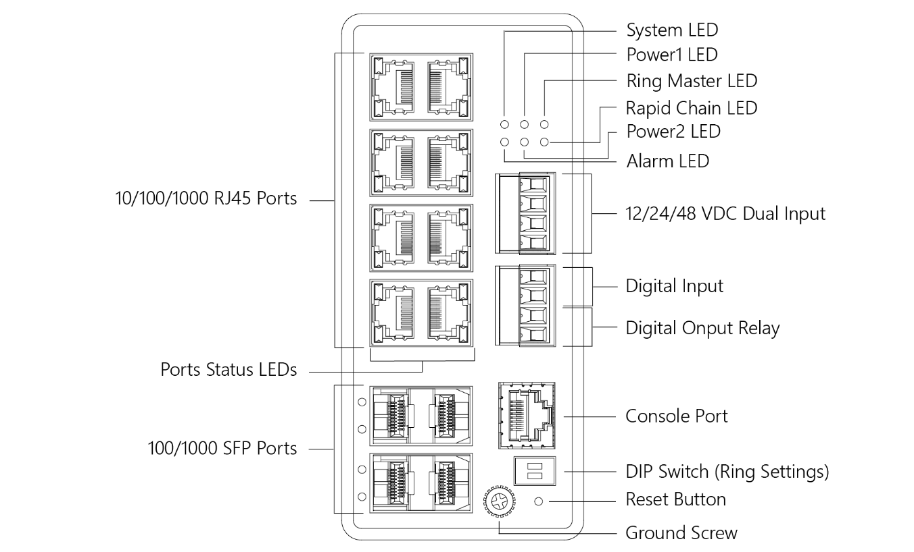
Figure 1: Front panel of the switch

Rear View of the Switch
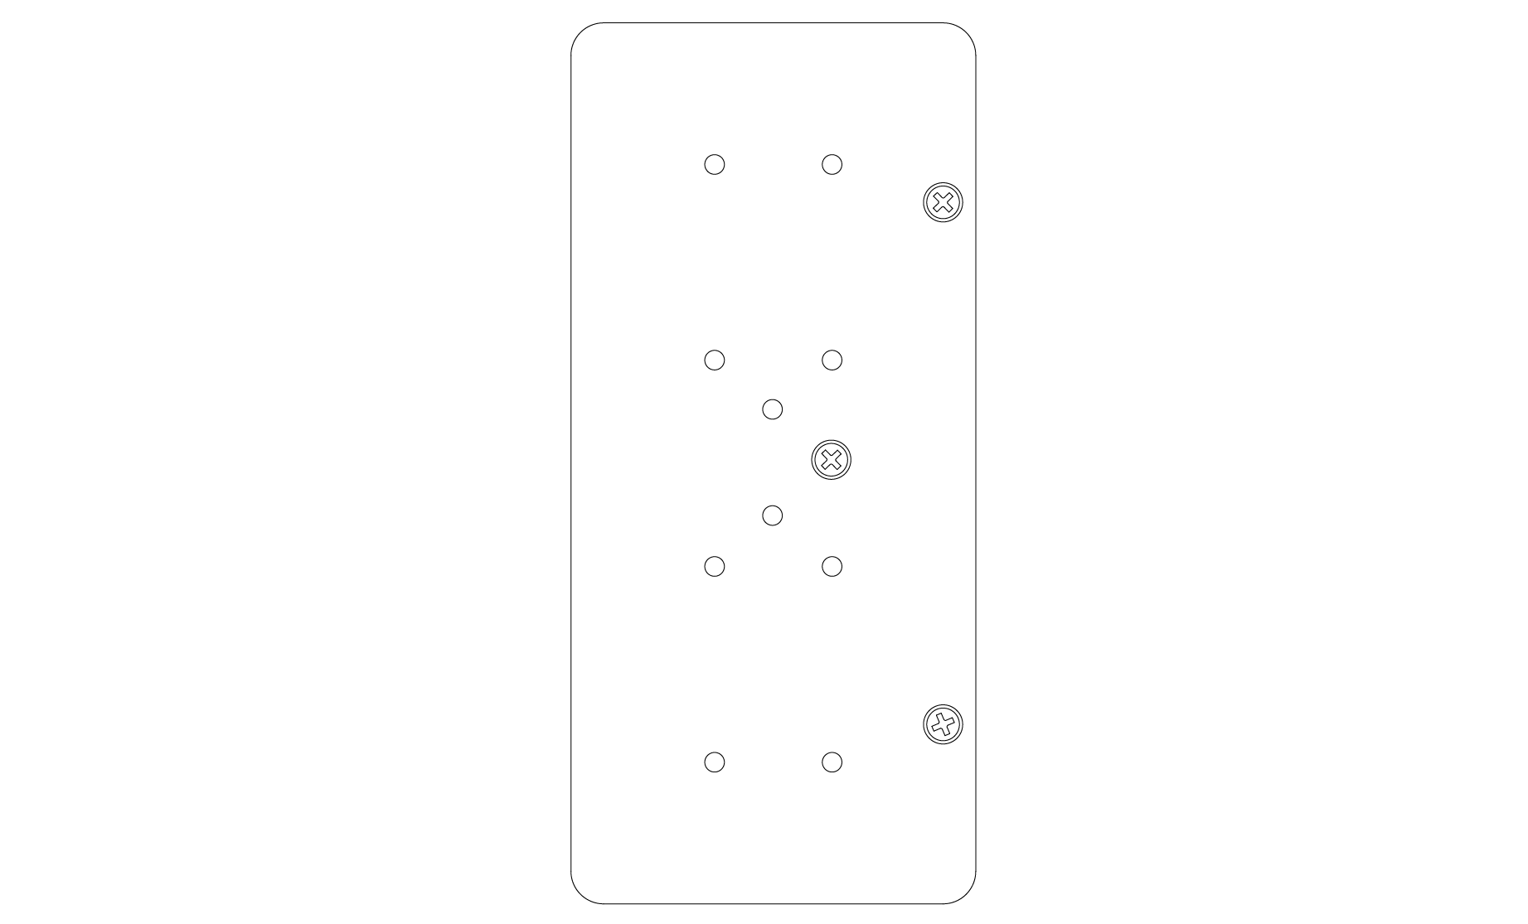
Figure 2: Rear panel of the switch

LED Descriptions
The LEDs on the front panel provide users with switch status checking and monitoring. There are three types of LEDs as follows:
- Power LEDs
indicates if the switch is powered up correctly or not.
- System LED
indicates if the system is ready or not.
- Alarm LED
indicates if the system is normal or not.
- Ring Master and Rapid Chain LED
indicates if the Rapid Ring is ready or not.
- Port Status LEDs
indicates the current status of each port. Users can check these LEDs to understand the port status.

The following table details the functions and descriptions of various LED indicators.
Table 1: Power LEDs
LED | Color | State | Description
Power1 | Green | On | The switch is powered ON correctly.
 |  | Off | The switch is not receiving power from power1.
Power2 | Green | On | The switch is powered ON correctly.
 |  | Off | The switch is not receiving power from power2.

Table 2: System LED
LED | Color | State | Description
System | Green | On | The switch is ready.
 |  | Off | The switch is not ready.

Table 3: Alarm LED
LED | Color | State | Description
Alarm | Red | On | An abnormal state, such as temperature, voltage or DC power1/2, has been detected in the switch.
 |  | Off | The system is normal.

Table 4: Ring Master and Rapid Chain LED
LED | Color | State | Description
RM  (Ring Master) | Green | On | Ring Master has been detected in the switch.
 | Amber | On | Ring Member has been detected in the switch.
 | -- | Off | Disable
RC  (Rapid Chain) | Green | On | Rapid Chain has been detected in the switch. (Active path)
 | Amber | On | Rapid Chain has been detected in the switch. (Backup path)
 |  | Blinking | Error:  There is no correspondent Rapid Chain Switch found.
 | -- | Off | Disable

Users can check the port status by reading the LED behaviors per the table below.
Table 5: Port Status LEDs
LED | Color | State | Description
RJ45 Ports  UP | Green | On | The port is enabled and established a link to connected device, and the connection speed is 1000Mbps.
 | Green | Blinking | The port is transmitting/receiving packets, and the connection speed is 1000Mbps.
 | Amber | On | The port is enabled and established a link to connected device, and the connection speed is 10/100Mbps.
 | Amber | Blinking | The port is transmitting/receiving packets, and the connection speed is 10/100Mbps.
 | -- | Off | The port has no active network cable connected, or it is not established a link to connected device. Otherwise, the port may have been disabled through the switch user interface.
SFP Ports | Green | On | The port is enabled and established a link to connected device, and the connection speed is 1000Mbps.
 | Green | Blinking | The port is transmitting/receiving packets, and the connection speed is 1000Mbps.
 | Amber | On | The port is enabled and established a link to connected device, and the connection speed is 100Mbps.
 | Amber | Blinking | The port is transmitting/receiving packets, and the connection speed is 100Mbps.
 | -- | Off | The port has no active network cable connected, or it is not established a link to connected device. Otherwise, the port may have been disabled through the switch user interface.

DIP Switch
By configure the DIP Switch, users can perform the Rapid Ring tasks.
Detail setting can refer to Rapid Ring User Manual.

Reset Button
By pressing the Reset Button for certain period of time, users can perform the following tasks.
- Reset the Switch
to reboot and get the switch back to the previous configuration settings saved.
- Restore the Switch to Factory Defaults
to restore the original factory default settings back to the switch.
Note:
According to the table below, users can easily judge which task is being performed by reading the LED behaviors while pressing the Reset button. Once the LED behaviors are correctly displayed, users may just release the button.

Table 6: Reset Button Descriptions
Task to be Performed | Time Period of Pressing Button | SYS LED  Behavior | Port Status LED  Behavior
Reset the Switch | 2 ~ 7 seconds | Blinking  Green | ALL LEDs Light OFF
Restore to Defaults | 7 ~ 12 seconds | Blinking  Green | ALL LEDs Stay ON

Chapter 2 Installing the Switch

Package Contents
- The Switch
- Terminal Block
- Installation Guide
- Mounting kit
- RJ45 to DB9 Serial Console Cable (Option)

Mounting the Switch on a DIN Rail

Step 1: Attach the DIN Rail mounting kit to rear panel of the chassis. Insert screws and tighten then with a screwdriver to secure the kit.
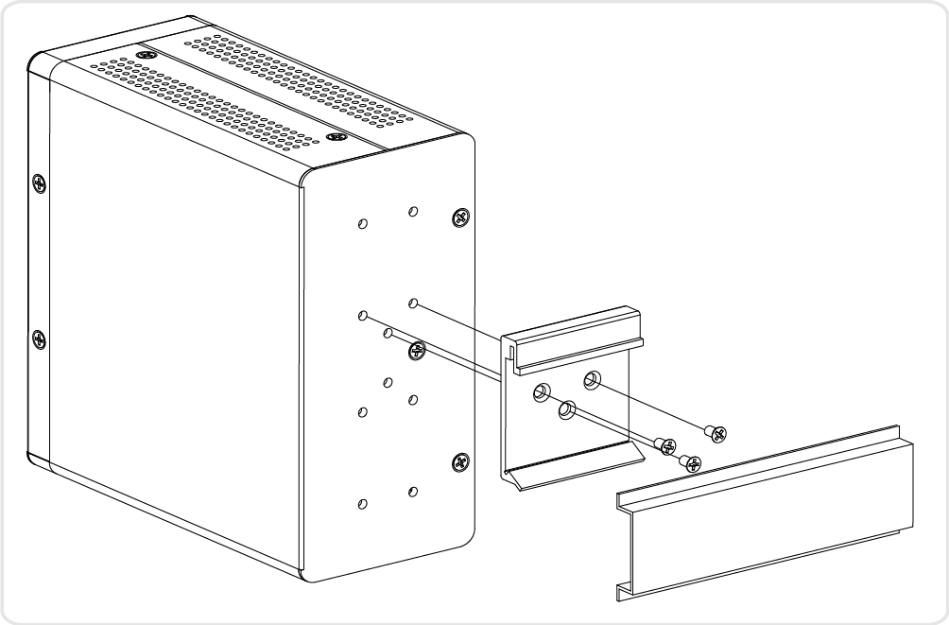
Figure 3: Attaching DIN Rail Kit to the Switch

Step 2: Insert the upper lip of the DIN rail into the DIN-rail mounting kit. And press the switch towards the DIN rail until it snaps into place.

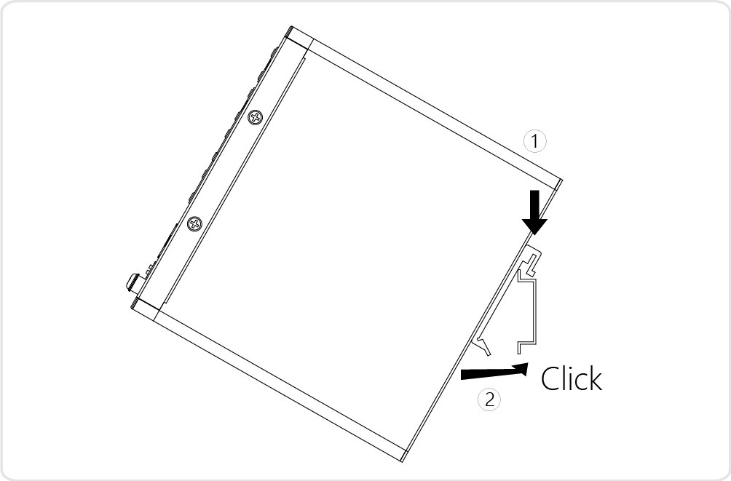
Figure 4: Insert switch to the DIN Rail

Step 3: Make sure that the switch is attached securely to DIN Rail.
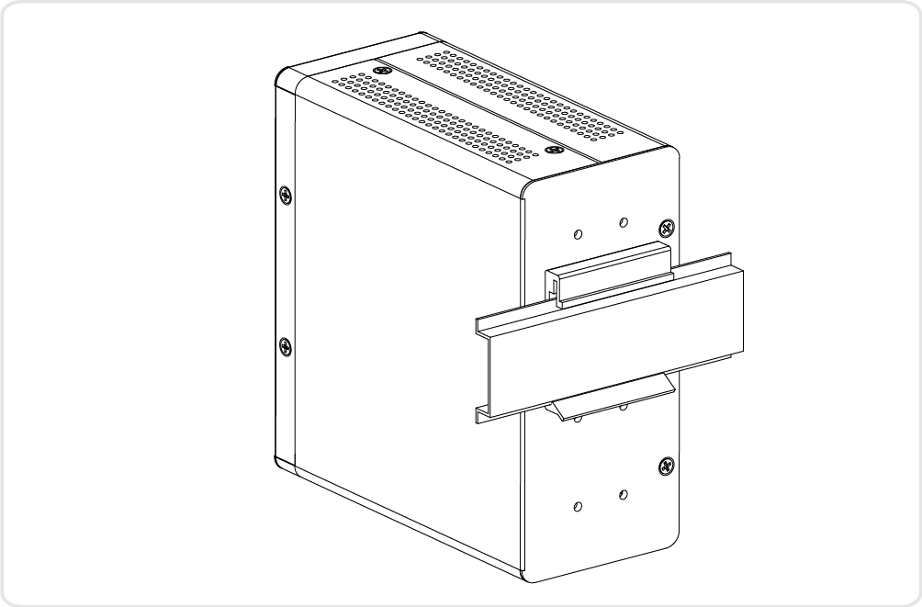
Figure 5: The switch is attached to DIN Rail

Mounting the Switch on Wall (Optional)
Step 1: Attach the wall mounting plates to rear panel of the chassis. Insert screws and tighten then with a screwdriver to secure the plates.
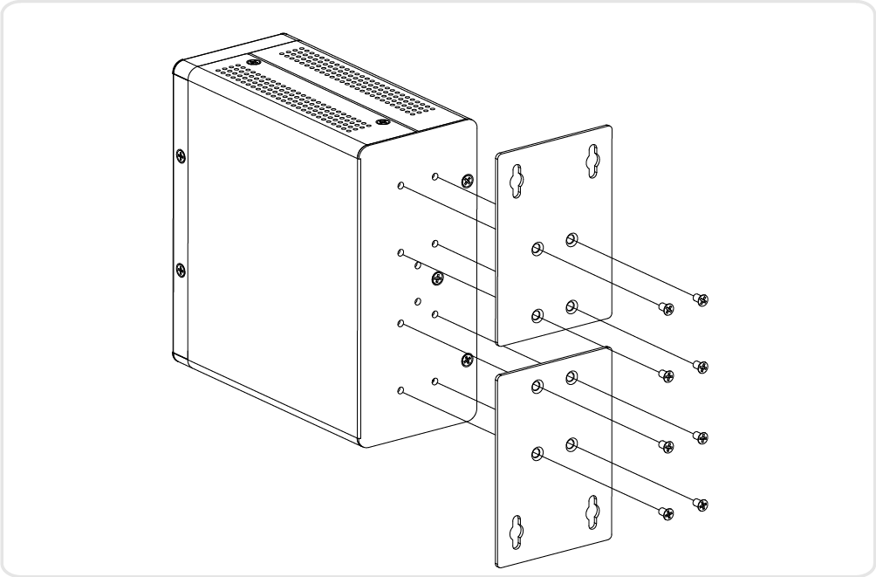
Figure 6: Attaching Wall Mounting Plates to the Switch

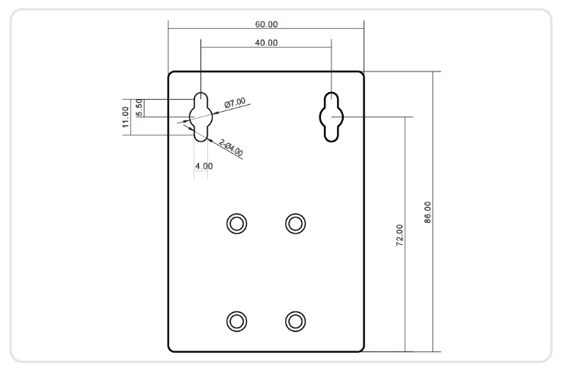
Figure 7: The Dimension of Wall Mounting Plates

Step 2: Install user-supplied screws on the appropriate location on the wall.
Step 3: Make sure that the switch is attached securely to wall.

Connecting the DC Power Cord
Step 1: Insert the negative/positive DC wires into the V-/V+ terminals, respectively.
Step 2: To keep the DC wires from pulling loose, use a small flat-blade screwdriver to tighten the wire-clamp screws on the front of the terminal block connector.
Step 3: Insert the terminal block connector prongs into the terminal block receptor.
Step 4: Check the SYS LED. If it is ON, the power connection is correct.

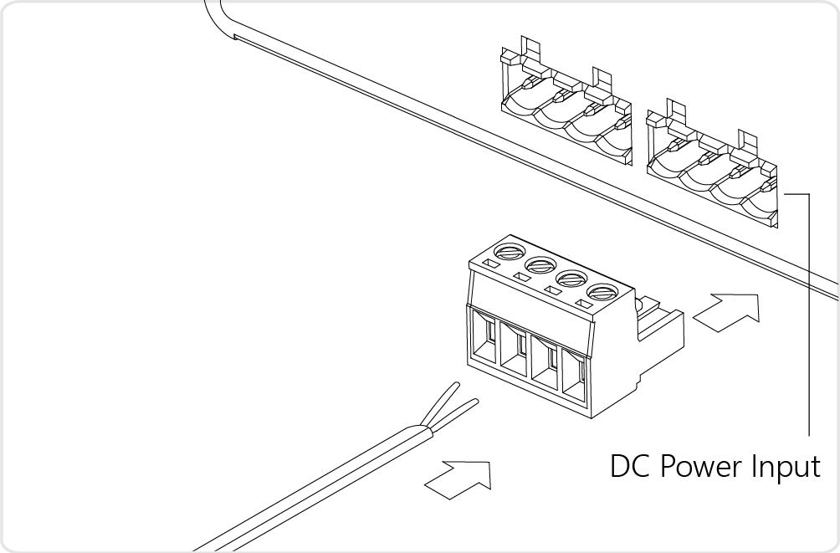
Figure 8: Connecting DC power cord
WARNING:
Safety First Turn the power off before connecting or disconnecting modules or wires. The correct power supply voltage is listed on the product label. Check the voltage of your power source to make sure that you are using the correct voltage. Do NOT use a voltage greater than what is specified on the product label.

Connecting the DI/DO Relay Wires
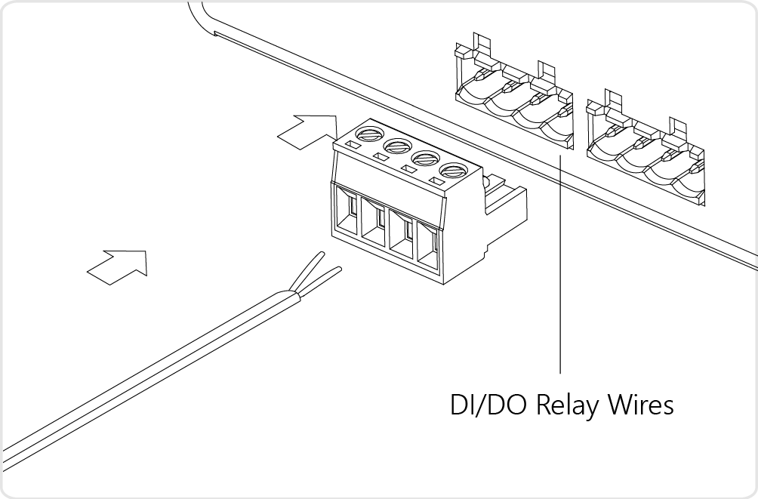
Figure 9: Connecting DI/DO Relay Wires

STEP 1: Insert the negative (ground)/positive DI/DO Relay wires into the +/- terminals, respectively.
STEP 2: To keep the DI/DO Relay wires from pulling loose, use a small flat-blade screwdriver to tighten the wire-clamp screws on the front of the terminal block connector.
STEP 3: Insert the terminal block connector prongs into the terminal block receptor.

Note:
Digital output (relay): 24VDC/1A
Digital input: level 0(Low) -> 0V to 6V, level 1 (High) -> 10V to 24V
FAULT:
The two contacts of the terminal block connector are used to detect user-configured events. The two wires attached to the fault contacts form an open circuit when a user-configured event is triggered. If a user-configured event does not occur, the fault circuit remains closed.

Installing SFP Modules
You can install or remove a mini-GBIC SFP module from a SFP port without having to power off the switch.
Step 1: Insert the module into the SFP port.
Step 2: Press firmly to ensure that the module seats into the connector.
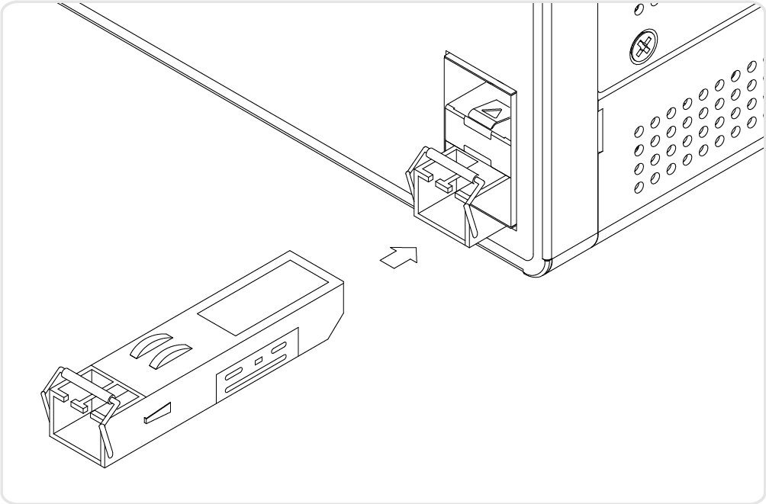
Figure 10: Installing a SFP Module into a SFP Port
Note:
The SFP ports should use UL Listed Optional Transceiver product, Rated 3.3Vdc, Laser Class 1.

Chapter 3 Initial Configuration of Switch

Initial Switch Configuration Using Web Browsers
After powering up the switch for the first time, you can perform the initial switch configuration using a web browser. For managing other switch features, please refer to the Web interface user guide for details.
To begin with the initial configuration stage, you need to reconfigure your PC’s IP address and subnet mask so as to make sure the PC can communicate with the switch. After changing PC’s IP address (for example, 192.168.1.250), then you can access the Web interface of the switch using the switch’s default IP address as shown below.
The initial switch configuration procedure is as follows:
Note:
The factory default IP address of the switch is 192.168.1.1
The factory default Subnet Mask of switch is 255.255.255.0

Initial Switch Configuration Procedure
The initial switch configuration procedure is as follows:
- Power up the PC that you will use for the initial configuration. Please make sure the PC has the Ethernet RJ45 connector to be connected to the switch via standard Ethernet LAN cable.
- Reconfigure the PC’s IP address and Subnet Mask as below, so that it can communicate with the switch. The method to change the PC’s IP address, for example, for a PC running Windows® 7/8.x/10, is as follows:
Step 1: Type “network and sharing“ into the Search box in the Start Menu
Step 2: Select Network and Sharing Center
Step 3: Click on Change adapter settings on the left of PC screen
Note:
Users can also skip step 1 to 3, by pressing WinKey+R and type ”ncpa.cpl” command to get to step 4 directly.

Step 4: Right-click on your local adapter and select Properties
Step 5: In the Local Area Connection Properties window highlight Internet Protocol Version 4 (TCP/IPv4) then click the Properties button.
Note:
Be sure to record all your PC’s current IP settings to be able to restore them later.
Step 6: Select the radio button Use the following IP address and enter in the IP for the PC (e.g. any IP address not in use, and in between 192.168.1.2 and 192.168.1.254), Subnet mask (e.g. 255.255.255.0), and Default gateway that corresponds with your network setup. Then enter your Preferred and Alternate DNS server addresses.
Step 7: Click OK to change the PC’s IP address.
- Power up the switch to be initially configured, and wait until it has finished its start-up processes.
- Connect the PC to any port on the switch using a standard Ethernet cable, and check the port LED on the switch to make sure the link status of the PC’s is OK.
- Run your Web browser on the PC, enter the factory default IP address, so as to access the switch’s Web interface.
If your PC is configured correctly, you will see the login page of the switch as shown by Figure 9 below.
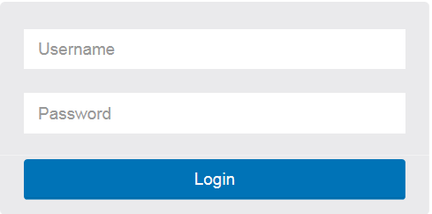
Figure 11: Web Interface login page
If you do not see the above login page, please perform the following steps:
- Refresh the web page.
- Check to see if there is an IP conflict issue.
- Clean browser cookies and temporary internet files.
- Check your PC settings again and repeat step 2.
- Enter the factory default username and password in login page.
Click “Login” to log into the switch.
Note:
The factory default Username of the switch is admin.
There is no factory default Password of the switch.

Chapter 4 Troubleshooting
The following table provides information for users to easily troubleshoot problems by taking actions based on the suggested solutions within.
Table 7: Troubleshooting Table
Symptoms | Possible Causes | Suggested Solutions
SYSTEM LED is Off | The switch is not receiving power. | 1. Check if correct power cord is connected firmly to the switch and to the DC outlet socket.  2. Perform power cycling the switch by unplugging and plugging the power cord back into the switch.  3. If the LED is still off, try to plug power cord into different DC outlet socket to make sure correct DC source is supplied.
Port Up Status LED is Off | The port is not connected or the connection is not working. | 1. Check if the cable connector plug is firmly inserted and locked into the port at both the switch and the connected device.  2. Make sure the connected device is up and running correctly.  3. If the symptom still exists, try different cable or different port, in order to identify if it is related to the cable or specific port.  4. Check if the port is disabled in the configuration settings via WEB user interface .

